Predicting Diabetes Risk Using Machine Learning
CSP 571 — Machine Learning | Spring 2025
Team Members: Yaswanth Moapda | Srujith Borra | Uday Ankam
Dataset: CDC BRFSS 2015 Health Indicators — https://archive.ics.uci.edu/dataset/891/cdc+diabetes+health+indicators

1. Introduction
Diabetes is one of the most common chronic diseases in the United States, affecting millions of people every year. The problem is that a lot of people don't even know they have it until it's already progressed. So the idea behind this project was to see if we could use machine learning to predict diabetes risk using basic health and lifestyle information that most people already know about themselves — things like BMI, age, blood pressure, and whether they exercise regularly.
The dataset we used comes from the CDC's Behavioral Risk Factor Surveillance System (BRFSS) from 2015. It includes survey responses from over 70,000 people and has 21 features related to health behaviors and conditions. The target variable is binary — either the person has diabetes or they don't. We downloaded it from the UCI Machine Learning Repository.
We trained six different machine learning models and compared them to figure out which one does the best job at predicting diabetes. The models we used were Logistic Regression, Lasso, Random Forest, Gradient Boosting (GBM), Support Vector Machine (SVM), and a Neural Network. All analysis was done in R.

2. Dataset and Preprocessing
We used the file diabetes_binary_5050split_health_indicators_BRFSS2015.csv, which already comes with a roughly balanced split between diabetic and non-diabetic cases. The raw file had 70,692 rows and 22 columns including the target variable. The dataset is publicly available at: https://archive.ics.uci.edu/dataset/891/cdc+diabetes+health+indicators.
Before doing anything with the data, we did a few cleaning steps:
- Removed 1,635 duplicate rows, leaving 69,057 unique records.
- Downsampled both classes to 33,960 rows each to get a perfectly balanced 50/50 dataset (67,920 rows total). This is important because class imbalance can make a model look good just by always predicting the majority class.
- Converted 14 binary features like HighBP, Smoker, Stroke, HeartDiseaseorAttack, DiffWalk, Sex etc. into factors so R handles them correctly during model training.
- Z-score standardized all 7 continuous features — BMI, Age, GenHlth, MentHlth, PhysHlth, Education, and Income. This is especially important for models like Logistic Regression and SVM that are sensitive to feature scale.
After preprocessing, we split the data 70/30 into a training set (47,544 rows) and a held-out test set (20,376 rows) using stratified sampling to keep the 50/50 class balance in both partitions.

3. Exploratory Data Analysis
Before jumping into model training, we spent some time exploring the data to understand what features might be most useful and how they relate to the target variable. The figures below show the main things we found.
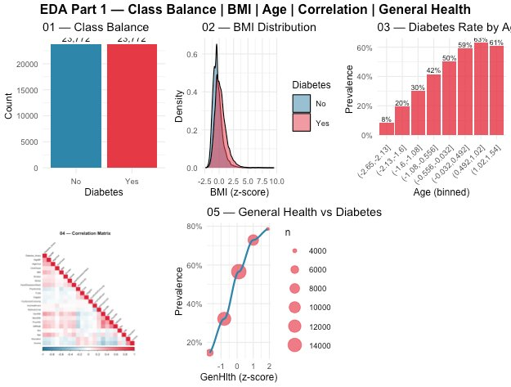
Figure 1 — EDA Part 1: Class balance, BMI distribution, diabetes rate by age group, feature correlation heatmap, and general health vs. diabetes prevalence.
From Figure 1, a few things stand out. First, the class balance bar chart (Plot 01) confirms our 50/50 split worked correctly — both classes have exactly 23,772 samples in the training set. The BMI density plot (Plot 02) shows that people with diabetes tend to have higher BMI values on average, which makes sense. The age chart (Plot 03) was one of the most interesting things we found — diabetes prevalence goes from just 8% in the youngest age group all the way up to 61% in the oldest group. This suggests age is a very strong predictor of diabetes risk.
The correlation heatmap (Plot 04) helped us understand which features are most related to the target variable. GenHlth, BMI, Age, and HighBP all have noticeable positive correlations with Diabetes_binary. On the other hand, Income and PhysActivity have negative correlations, meaning people who are more physically active or have higher income tend to be less at risk. Plot 05 shows a very clear trend — the worse someone rates their own general health, the higher their probability of having diabetes, almost in a straight line.
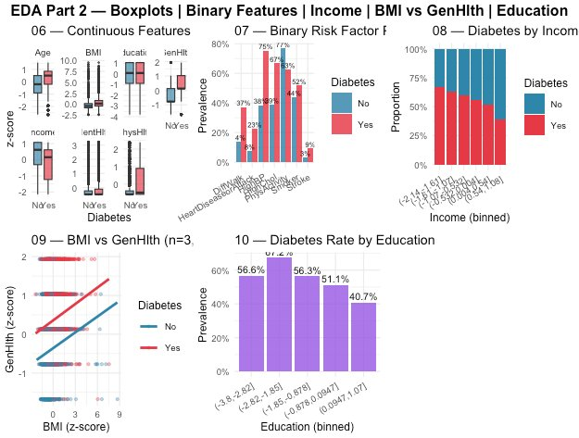
Figure 2 — EDA Part 2: Continuous feature boxplots, binary feature prevalence grouped bar, income vs. diabetes stacked bar, BMI vs. GenHlth scatter plot, and education vs. diabetes rate.
Figure 2 gives us more detail on individual features. The boxplots (Plot 06) show clear and consistent differences in almost every continuous feature between the two groups — diabetic patients have noticeably higher BMI and worse general health scores, and more bad physical health days. The binary feature chart (Plot 07) shows that HighBP is the most discriminating binary feature, with 67% of diabetic patients having high blood pressure compared to only 37% of non-diabetic patients. PhysActivity is also very telling — only 52% of diabetic patients are physically active versus 77% of non-diabetic patients.
Plot 08 shows a clear income effect — as income level increases, the proportion of diabetic cases decreases consistently, which reflects known socioeconomic health disparities. The scatter plot (Plot 09) shows that diabetic patients visually cluster toward higher BMI and worse general health scores. Finally, Plot 10 shows that lower education levels are associated with higher diabetes rates (56.6% prevalence at the lowest education level versus 40.7% at the highest), which again reflects known public health patterns around health literacy.

4. Models and Training
We trained six models in total. For the heavier models (Random Forest and GBM) we were able to use the full training set, but for SVM and the Neural Network we had to use a 10% stratified sub-sample of 4,756 rows because they were too slow to run on the full data within a reasonable time. Here is a summary of all models and their configurations:
Model | Training Data | Settings / Notes
Logistic Regression | Full set (47,544) | Standard binomial GLM, all 21 features included
Lasso (glmnet) | Full set (47,544) | alpha=1, lambda chosen by 5-fold CV — best lambda = 0.00082
Random Forest | Full set (47,544) | 300 trees, mtry=4, variable importance tracked
GBM | Full set (47,544) | 500 trees, interaction depth=3, shrinkage=0.05
SVM | 10% sub-sample (4,756) | Linear kernel, cost=1, probability output enabled
Neural Network | 10% sub-sample (4,756) | 1 hidden layer, 8 nodes, weight decay=0.01, 200 iterations

One thing worth mentioning is that because SVM and Neural Network are trained on much less data, their results might not be fully comparable to the other four models. Ideally we would have used the full dataset for all models, but given compute constraints this was the practical approach. Also, for the Lasso model, the best regularization parameter lambda was automatically selected through 5-fold cross-validation, and it came out at 0.00082 which is quite small — suggesting again that all features were useful and not much regularization was needed.

5. Results and Evaluation
After training, all six models were evaluated on the held-out test set of 20,376 rows. We used a decision threshold of 0.5 to convert predicted probabilities into class labels. The table below reports six evaluation metrics for each model, sorted from best to worst by AUC:
Model | Accuracy | Sensitivity | Specificity | Precision | F1 | AUC
GBM | 0.7486 | 0.7892 | 0.7081 | 0.7300 | 0.7584 | 0.8266
Logistic | 0.7456 | 0.7673 | 0.7239 | 0.7354 | 0.7510 | 0.8197
Lasso | 0.7454 | 0.7675 | 0.7233 | 0.7350 | 0.7509 | 0.8197
SVM | 0.7442 | 0.7629 | 0.7256 | 0.7354 | 0.7489 | 0.8183
RandomForest | 0.7411 | 0.7847 | 0.6974 | 0.7217 | 0.7519 | 0.8135
NeuralNet | 0.7266 | 0.7487 | 0.7046 | 0.7171 | 0.7325 | 0.7983

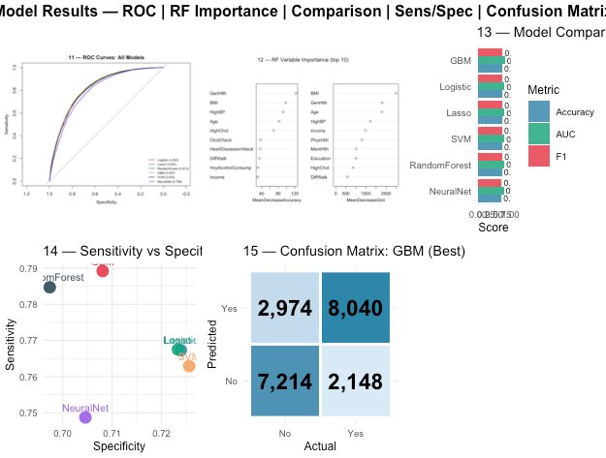
Figure 3 — Model results: ROC curves for all six models, Random Forest variable importance (top 10), model comparison bar chart, sensitivity vs. specificity scatter, and GBM confusion matrix.

5.1 Overall Performance
Looking at the results table, GBM came out on top with an AUC of 0.827 and accuracy of 74.9%. Logistic Regression and Lasso were very close behind, both with AUC of 0.820. Honestly, we were a bit surprised that Logistic Regression performed this well — it is the simplest model we trained but it almost matches GBM. This probably means the relationship between the features and the diabetes outcome is largely linear, and more complex models like Random Forest and GBM don't gain that much extra from capturing non-linear patterns. The Neural Network had the lowest performance overall (AUC = 0.798, accuracy = 72.7%), but as mentioned earlier this is likely because it only trained on 10% of the data — it probably would have done better with more.

5.2 ROC Curves (Plot 11)
The ROC curve plot shows all six models plotted together on the same axes. GBM clearly has the best curve — it stays highest in the upper-left corner, which means it achieves the best balance between catching true positives and avoiding false positives across all possible thresholds. All six models perform clearly above the random baseline (the diagonal line), which confirms that the 21 health features we used are genuinely predictive of diabetes status and not just noise.

5.3 Variable Importance — Random Forest (Plot 12)
The variable importance plot from the Random Forest model shows which features contributed most to its predictions. GenHlth and BMI were the two most important features by both Mean Decrease Accuracy and Mean Decrease Gini. Age, HighBP, and Income also ranked highly. This is very consistent with what we found in the EDA — those were the exact same features that showed the biggest visual differences between diabetic and non-diabetic groups, which was reassuring.

5.4 Sensitivity vs. Specificity Trade-off (Plot 14)
In a medical screening context, Sensitivity — the ability to correctly identify actual diabetic patients — is more important than Specificity, because missing a real diabetic case (false negative) is more harmful than incorrectly flagging a healthy person (false positive). From Plot 14, GBM and Random Forest both achieve the highest Sensitivity at 78.9% and 78.5% respectively, making them the most clinically useful models. SVM and Logistic Regression have slightly better Specificity but lower Sensitivity, meaning they are more conservative about labeling someone as diabetic.

5.5 Confusion Matrix — GBM (Plot 15)
The confusion matrix for GBM (our best model) on the 20,376-row test set shows: 8,040 true positives (diabetic patients correctly flagged), 7,214 true negatives (healthy patients correctly cleared), 2,974 false positives (healthy patients incorrectly flagged as diabetic), and 2,148 false negatives (diabetic patients that the model missed). In a real screening scenario the false negatives are the more serious concern because those are people with diabetes who would walk away thinking they are fine. GBM had the lowest false negative count of all six models at 2,148, which is another reason it is our recommended model.

6. Conclusion
This project showed that it is possible to predict diabetes risk with decent accuracy (around 75%) and strong discriminative power (AUC around 0.82–0.83) using only self-reported health survey data. We didn't use any blood test results or lab measurements — just answers people can give on a general health questionnaire. This is actually quite practical because it means a simple screening tool could potentially flag high-risk individuals without needing any clinical visits.
The best model overall was GBM, but Logistic Regression came very close which was a bit unexpected. The most important predictors across the board were general health self-rating, BMI, age, high blood pressure, and income level — all of which align well with what clinical and public health research already tells us about Type 2 diabetes risk factors, which gave us confidence the models were learning real patterns and not just fitting to noise.
If we were to extend this project, a few things we would want to try include running SVM and Neural Net on the full dataset for a fairer comparison, experimenting with ensemble stacking to combine predictions from multiple models, and tuning the decision threshold below 0.5 to push Sensitivity even higher for a real screening use case where missing diabetic patients is the bigger concern. We would also be curious to run the same pipeline on more recent BRFSS survey data to see if the predictive patterns have changed over time.
Overall, this was a great learning experience for applying the full machine learning pipeline — from raw data cleaning and exploratory analysis all the way through model training, evaluation, and interpretation — on a real-world public health dataset.

